|  |  |  |
| --- | --- | --- |
| **SANTA CLARA UNIVERSITY** | **ELEN 115**  **Spring 2023** | **Shoba Krishnan** |
| **Laboratory #5: Diode Rectifiers**  Noble Huang (Mulia Widjaja) | | |

**PRE-LAB**

1. For the diode circuit shown in Figure 1, consider the diode to be ideal. The input voltage vI given to the circuit is a sinusoid with a peak value of 10V.

For the circuit

1. Derive the expression for the transfer characteristic vOUT versus vI for the circuit.

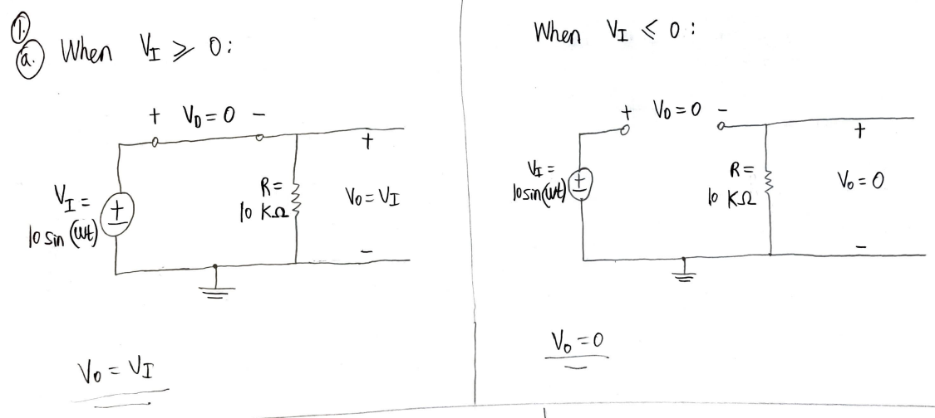

1. Plot the transfer characteristic vOUT versus vI indicating the values of all significant points and the values of the slopes of all segments.

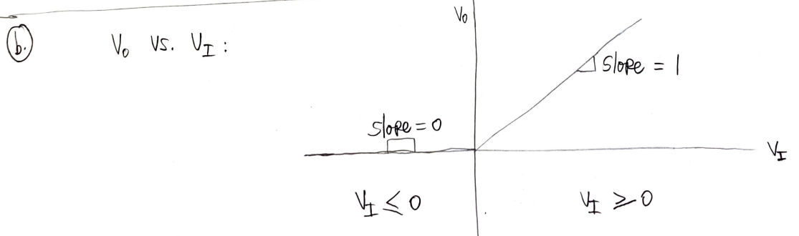

LTSpice Version:

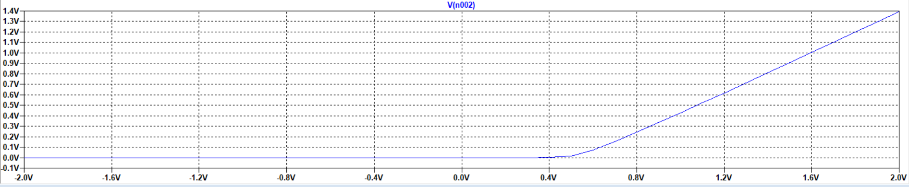

1. Draw the corresponding output voltage vOUT vs. time for two cycles of the the input vI

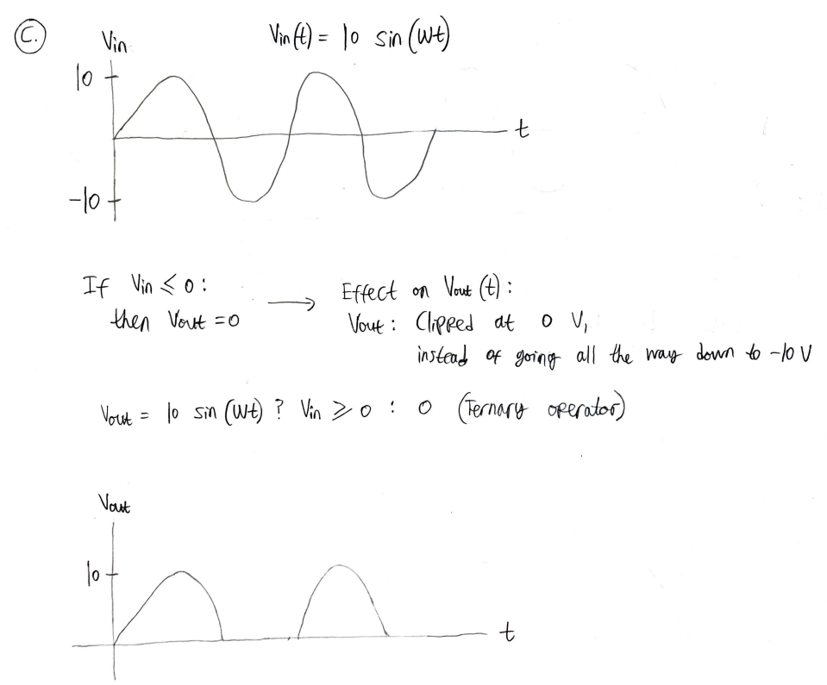

LTSpice Version:

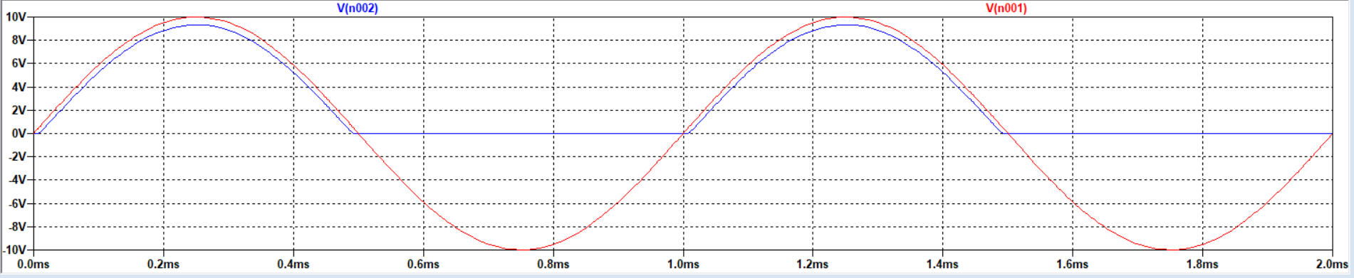

1. Find the peak diode current.

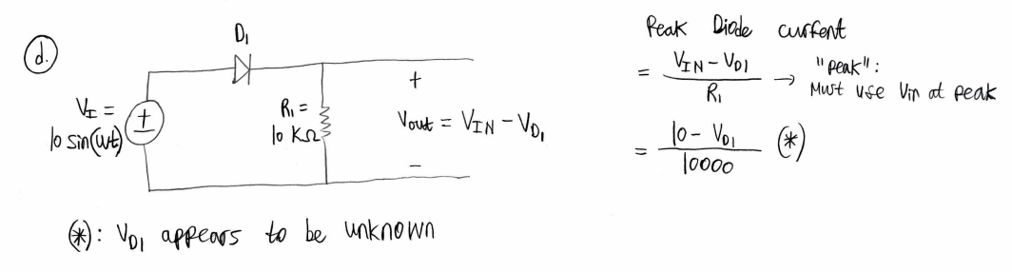

1. Find the maximum reverse voltage seen by the diode.

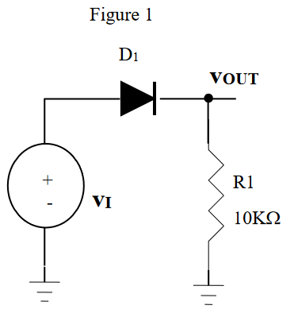

1. If a capacitor is connected **instead of** the resistor R1 in Figure 1, draw the corresponding output voltage vOUT vs. time for two cycles of the the input vI.

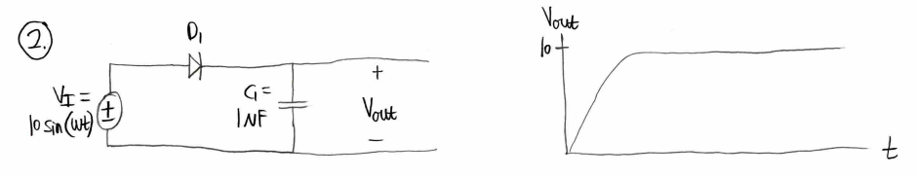

LTSpice Version:

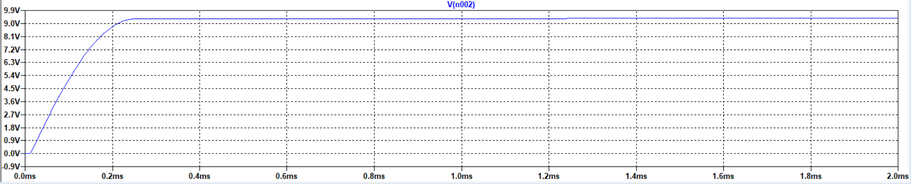

1. If a capacitor is connected **in parallel with** the resistor R1 in Figure 1, draw the corresponding output voltage vOUT vs. time for two cycles of the the input vI.

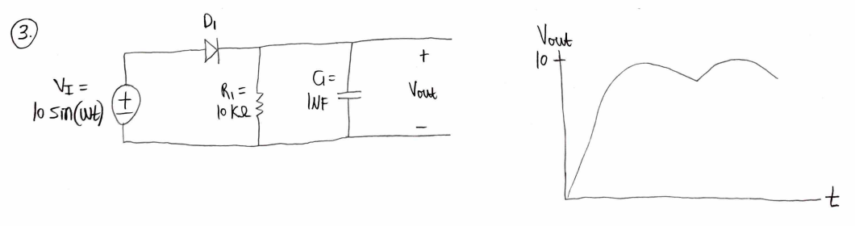

LTSpice Version:

